Solid Geometry

Definition
# Source: AI Source: Provided by: [Data Path: Persons Table -> ID Column: 1, Name_En Column: Motasem Essam] -> From: [ChatGPT] on [7/25/2026]
Solid Geometry is the branch of geometry that studies three-dimensional objects and the properties of shapes in space. It examines dimensions, faces, edges, vertices, angles, surface areas, volumes, and spatial relationships.
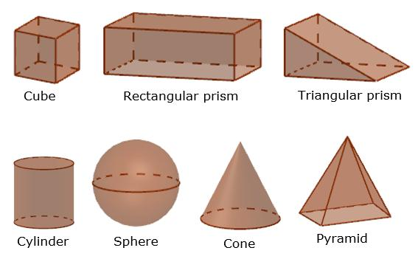s
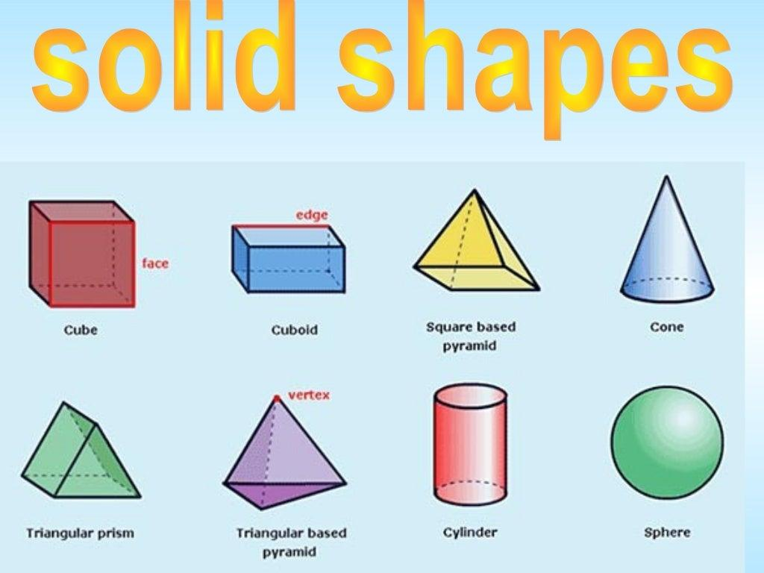
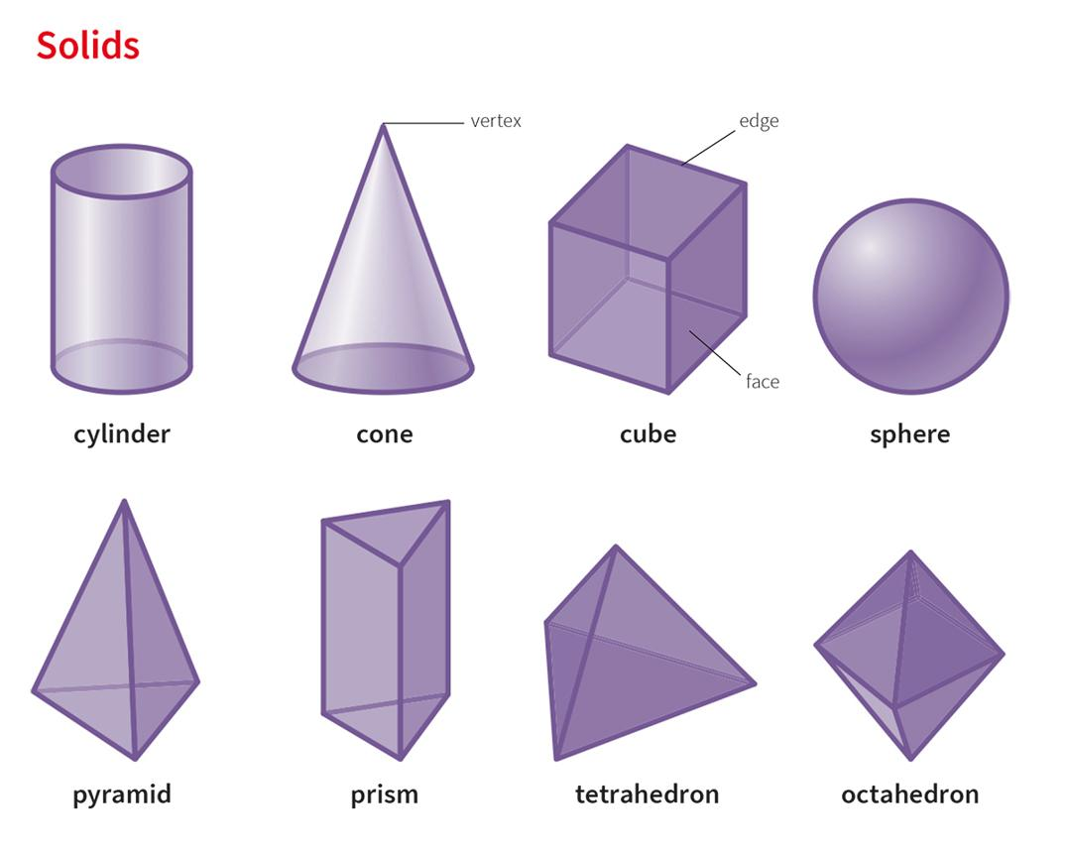
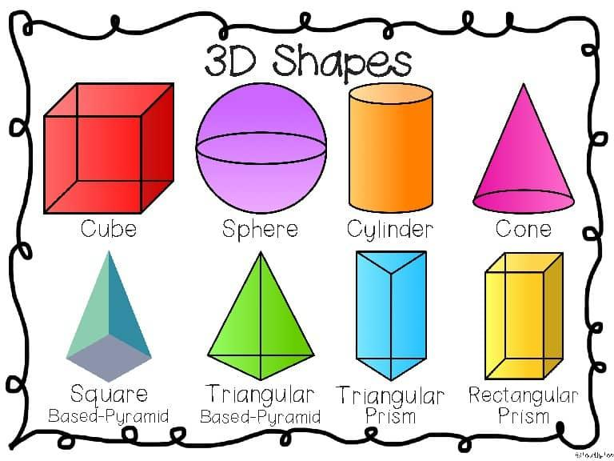
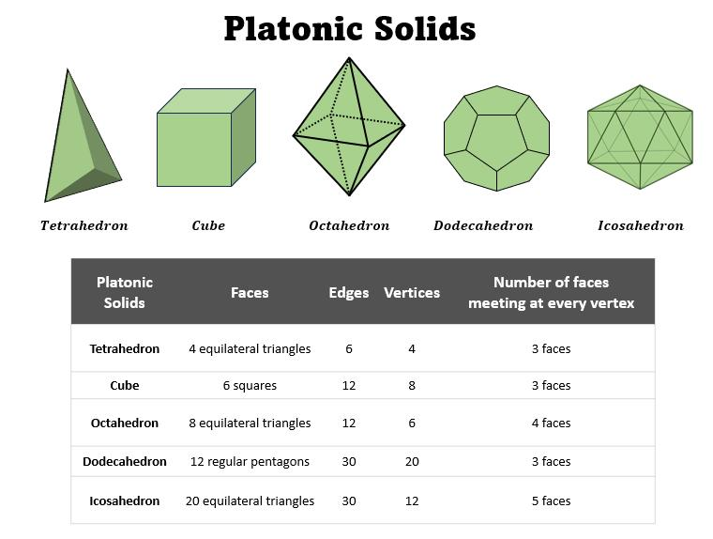
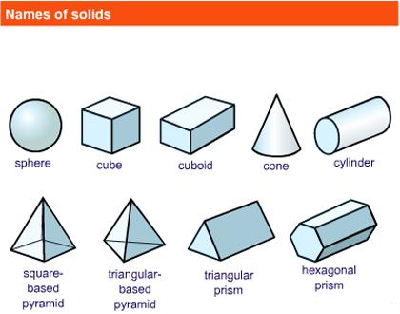
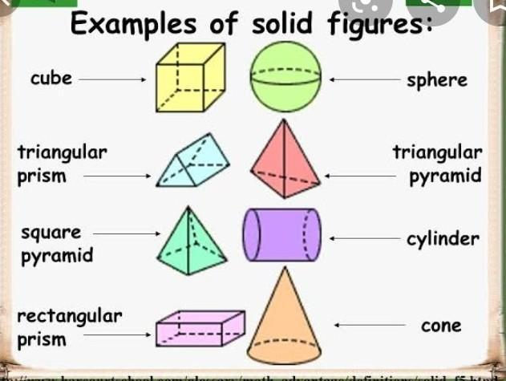
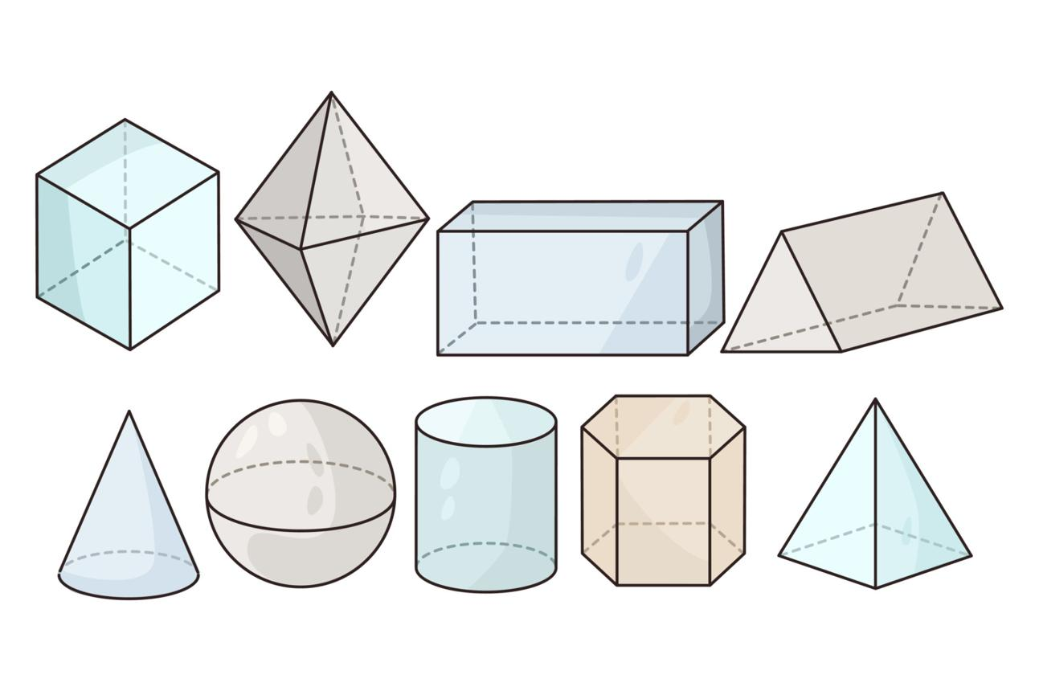

Simple Definition
# Source: AI Source: Provided by: [Data Path: Persons Table -> ID Column: 1, Name_En Column: Motasem Essam] -> From: [ChatGPT] on [7/25/2026]
Solid Geometry is the study of three-dimensional (3D) shapes that have length, width, and height.
Examples include cubes, cuboids, spheres, cylinders, cones, prisms, and pyramids.

Classification
# Source: AI Source: Provided by: [Data Path: Persons Table -> ID Column: 1, Name_En Column: Motasem Essam] -> From: [ChatGPT] on [7/25/2026]
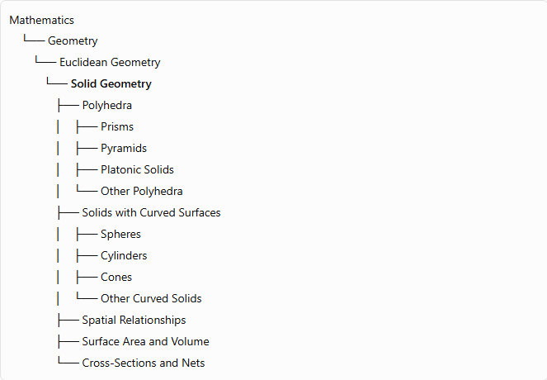
Mathematics
└── Geometry
└── Euclidean Geometry
└── Solid Geometry
├── Polyhedra
│ ├── Prisms
│ ├── Pyramids
│ ├── Platonic Solids
│ └── Other Polyhedra
├── Solids with Curved Surfaces
│ ├── Spheres
│ ├── Cylinders
│ ├── Cones
│ └── Other Curved Solids
├── Spatial Relationships
├── Surface Area and Volume
└── Cross-Sections and Nets
This is a practical classification for organizing geometry topics. Solid Geometry is commonly studied as the three-dimensional counterpart of Plane Geometry.

Fundamental Concepts
# Source: AI Source: Provided by: [Data Path: Persons Table -> ID Column: 1, Name_En Column: Motasem Essam] -> From: [ChatGPT] on [7/25/2026]
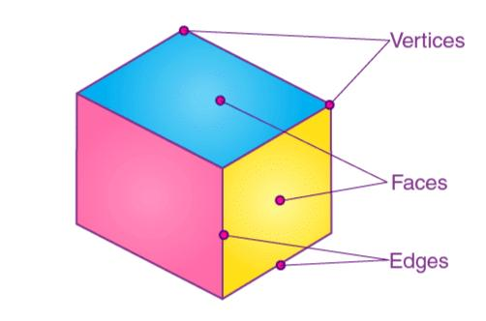
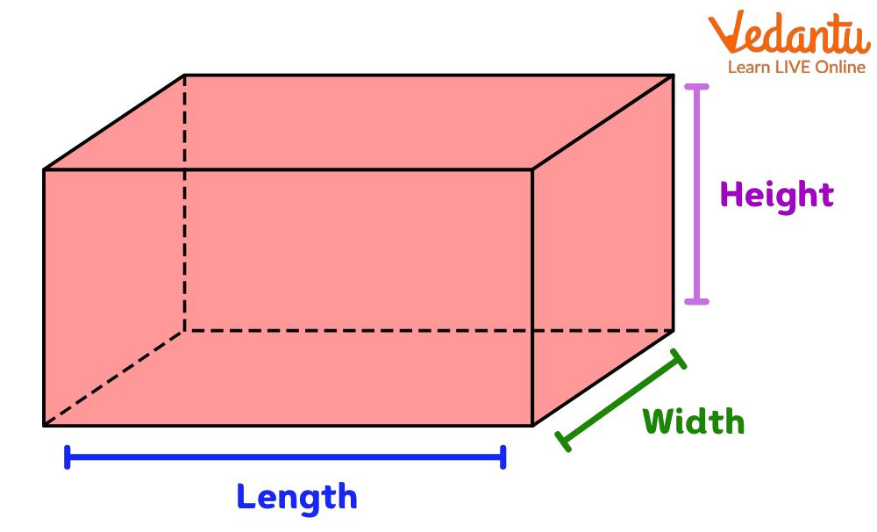
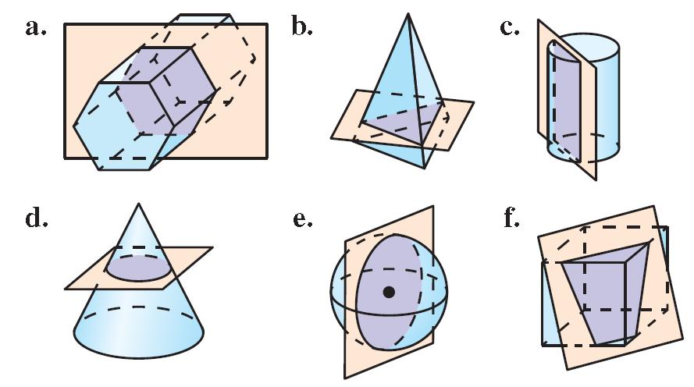
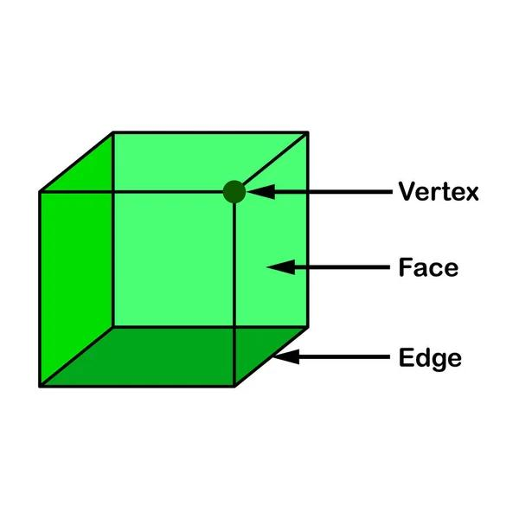
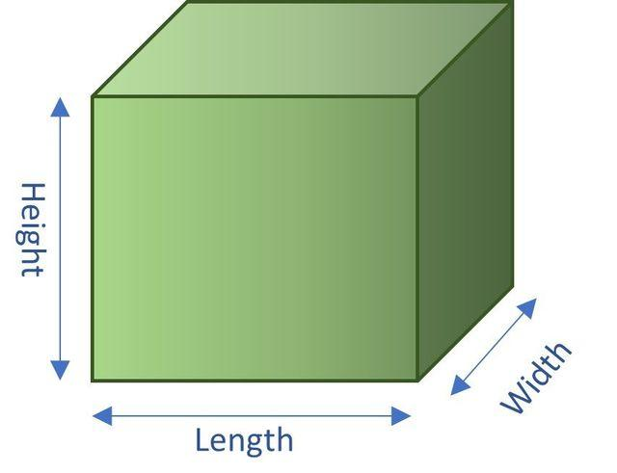
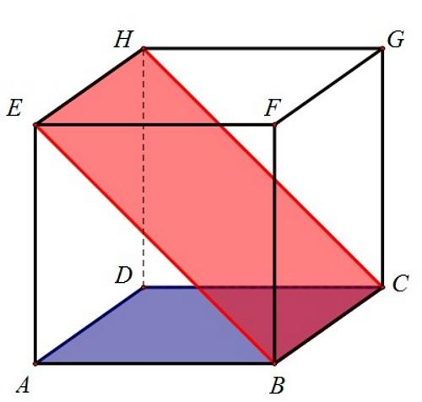
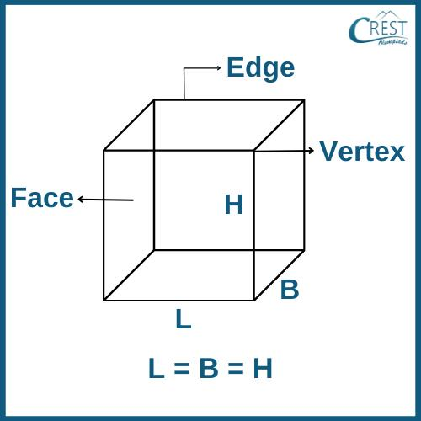
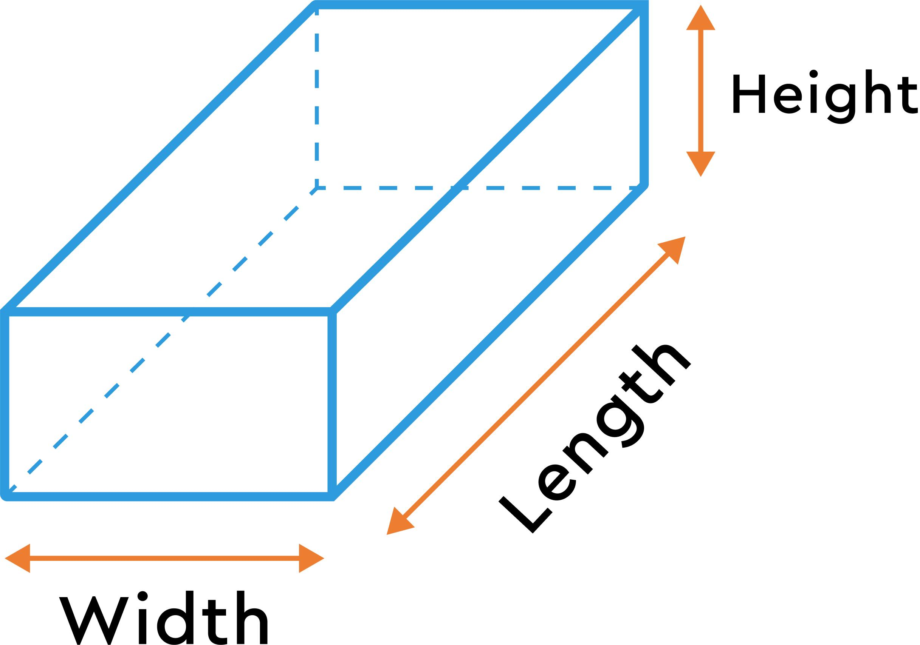
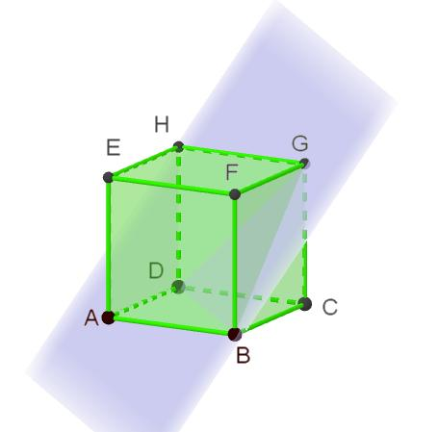
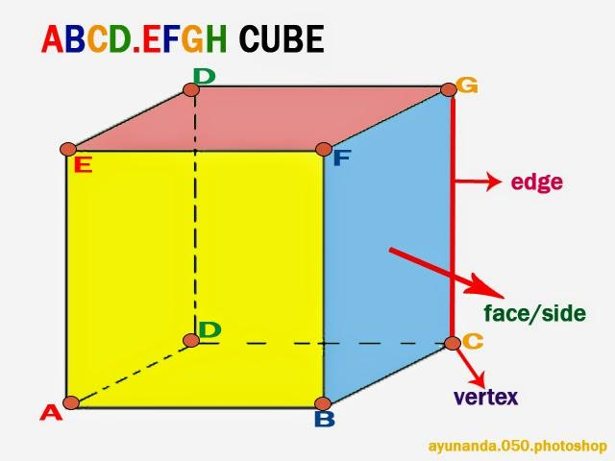
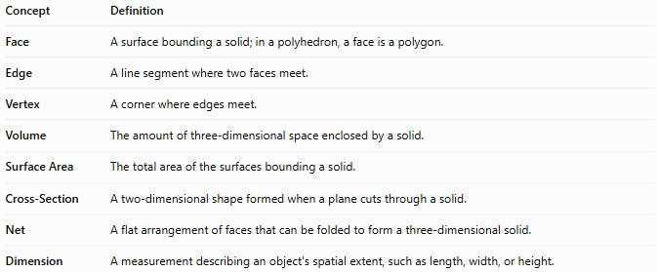
Concept | Definition
Face | A surface bounding a solid; in a polyhedron, a face is a polygon.
Edge | A line segment where two faces meet.
Vertex | A corner where edges meet.
Volume | The amount of three-dimensional space enclosed by a solid.
Surface Area | The total area of the surfaces bounding a solid.
Cross-Section | A two-dimensional shape formed when a plane cuts through a solid.
Net | A flat arrangement of faces that can be folded to form a three-dimensional solid.
Dimension | A measurement describing an object's spatial extent, such as length, width, or height.

Main Types of Solids

1 Polyhedra
# Source: AI Source: Provided by: [Data Path: Persons Table -> ID Column: 1, Name_En Column: Motasem Essam] -> From: [ChatGPT] on [7/25/2026]
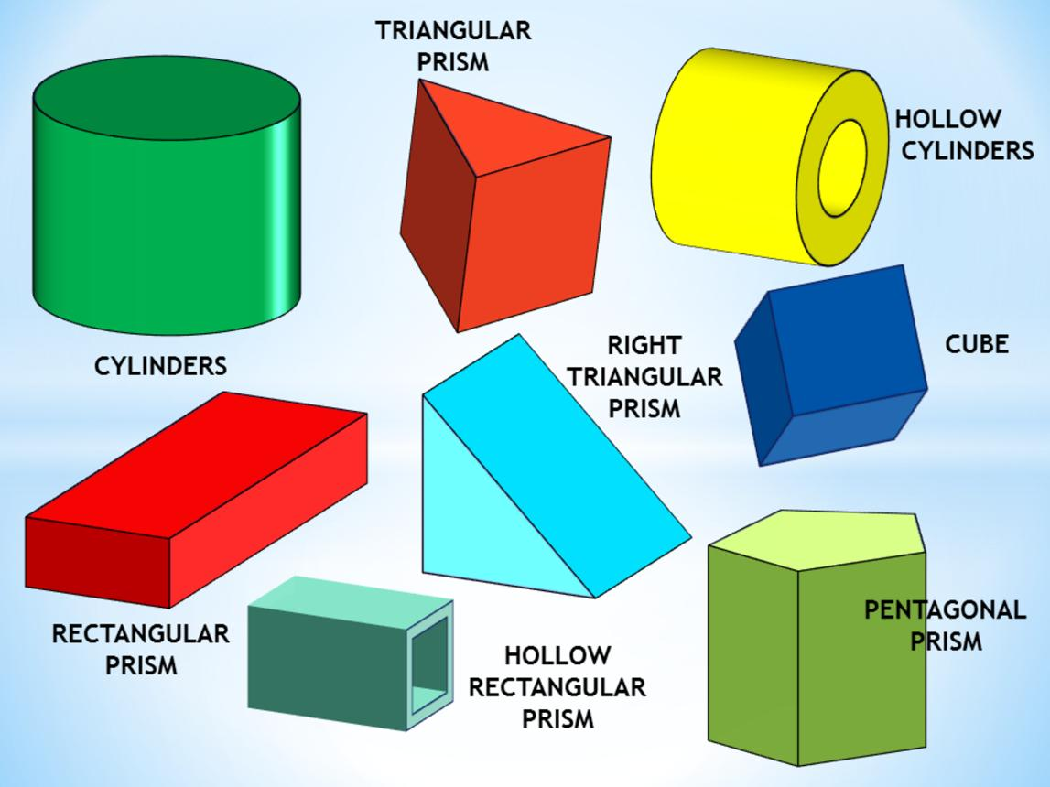
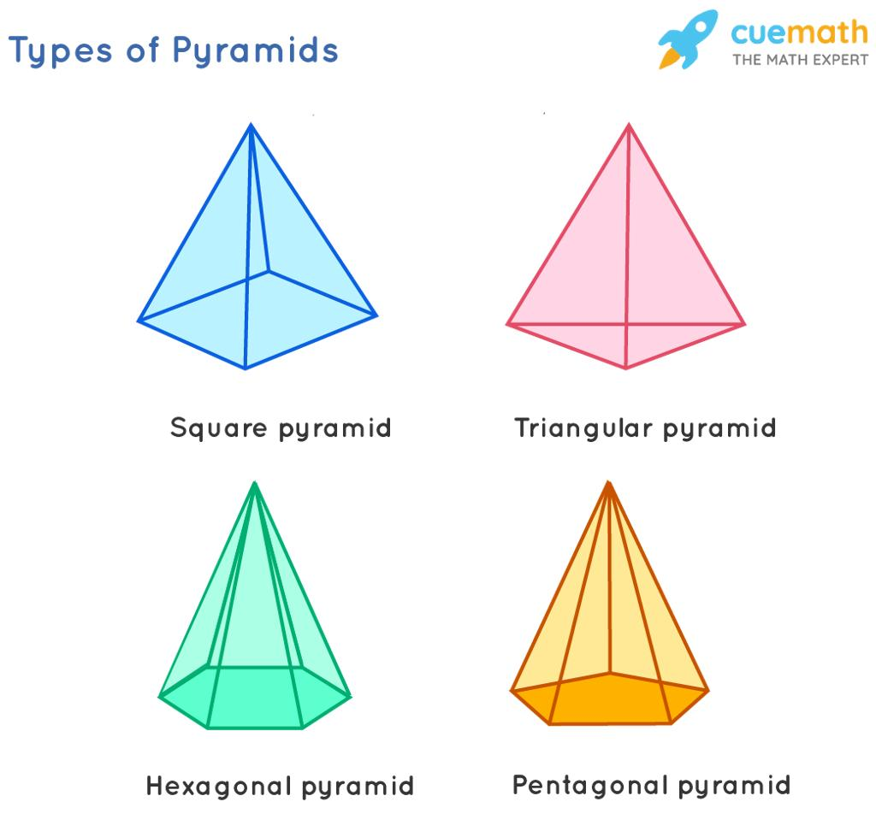
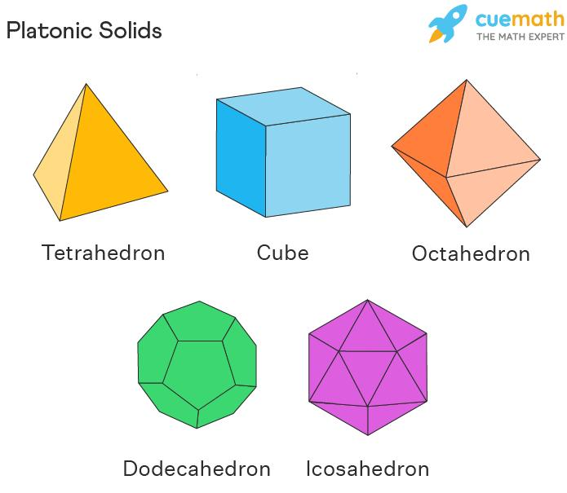
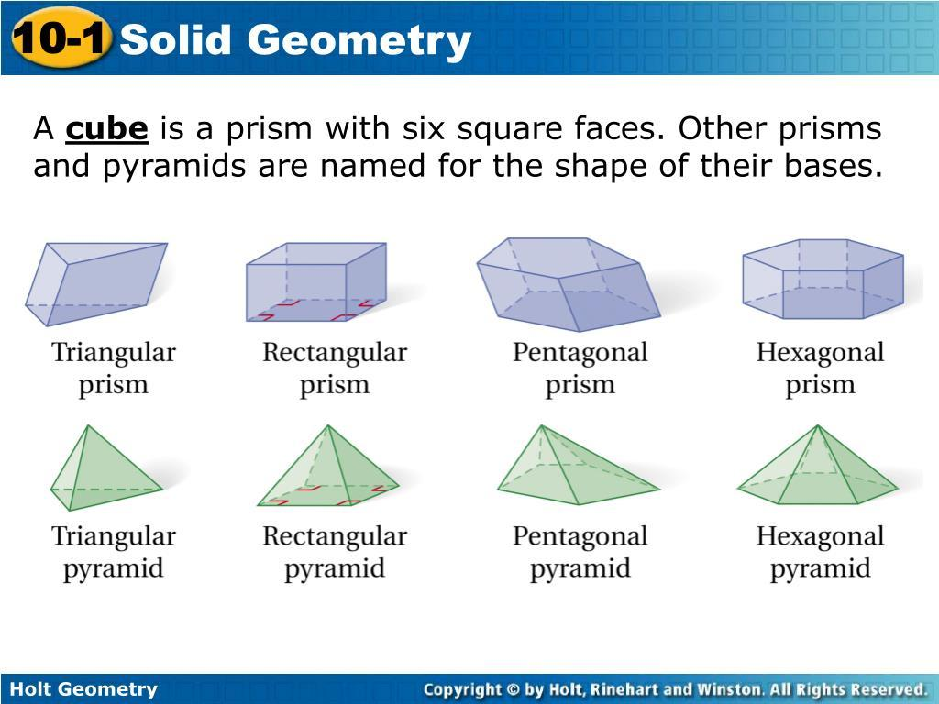
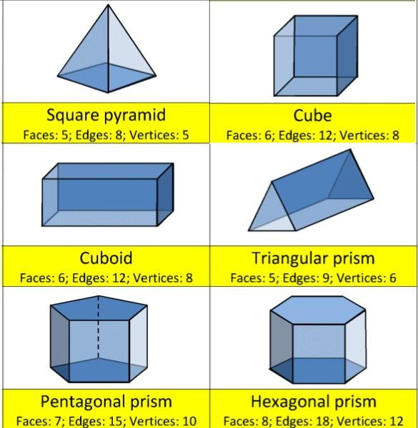
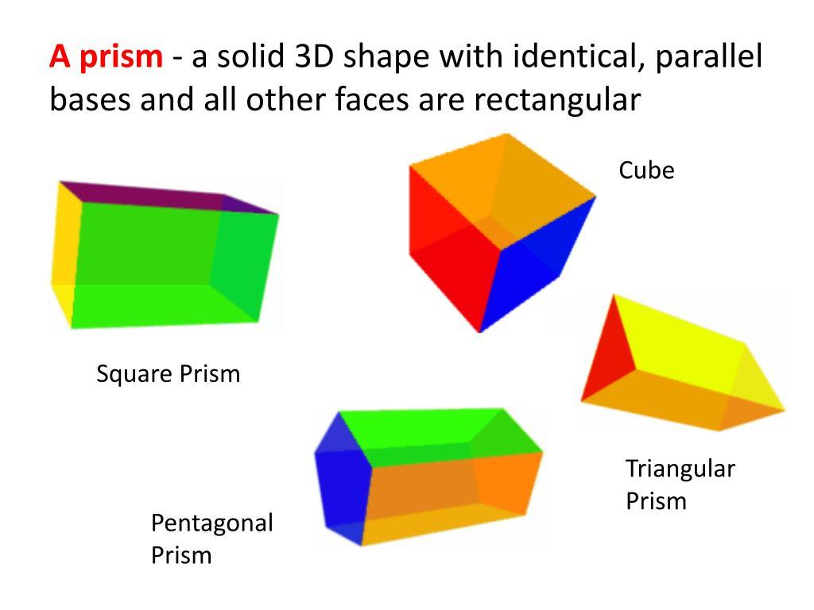
A polyhedron is a solid bounded entirely by flat polygonal faces.
- Prisms: Have two congruent, parallel bases joined by side faces.
- Pyramids: Have one polygonal base and triangular side faces meeting at a common apex.
- Platonic Solids: Five regular convex polyhedra with congruent regular polygon faces and the same arrangement of faces at each vertex.
- Other Polyhedra: Include convex, concave, and irregular polyhedra.
The five Platonic solids are the tetrahedron, cube, octahedron, dodecahedron, and icosahedron.

2 Solids with Curved Surfaces
# Source: AI Source: Provided by: [Data Path: Persons Table -> ID Column: 1, Name_En Column: Motasem Essam] -> From: [ChatGPT] on [7/25/2026]
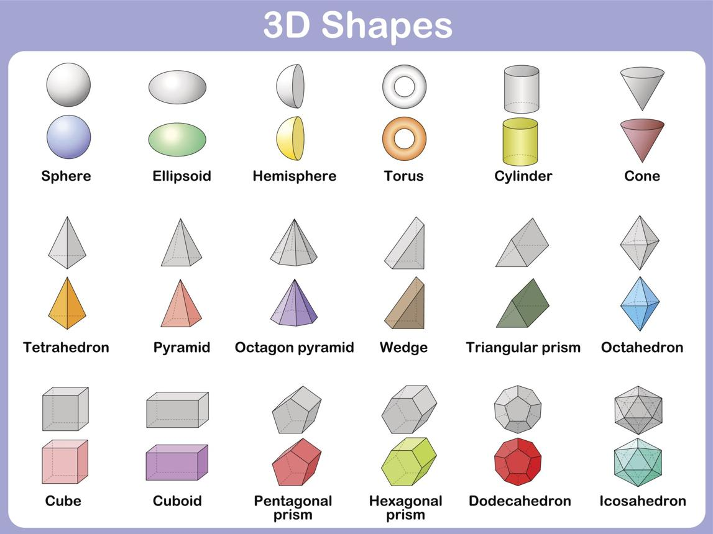
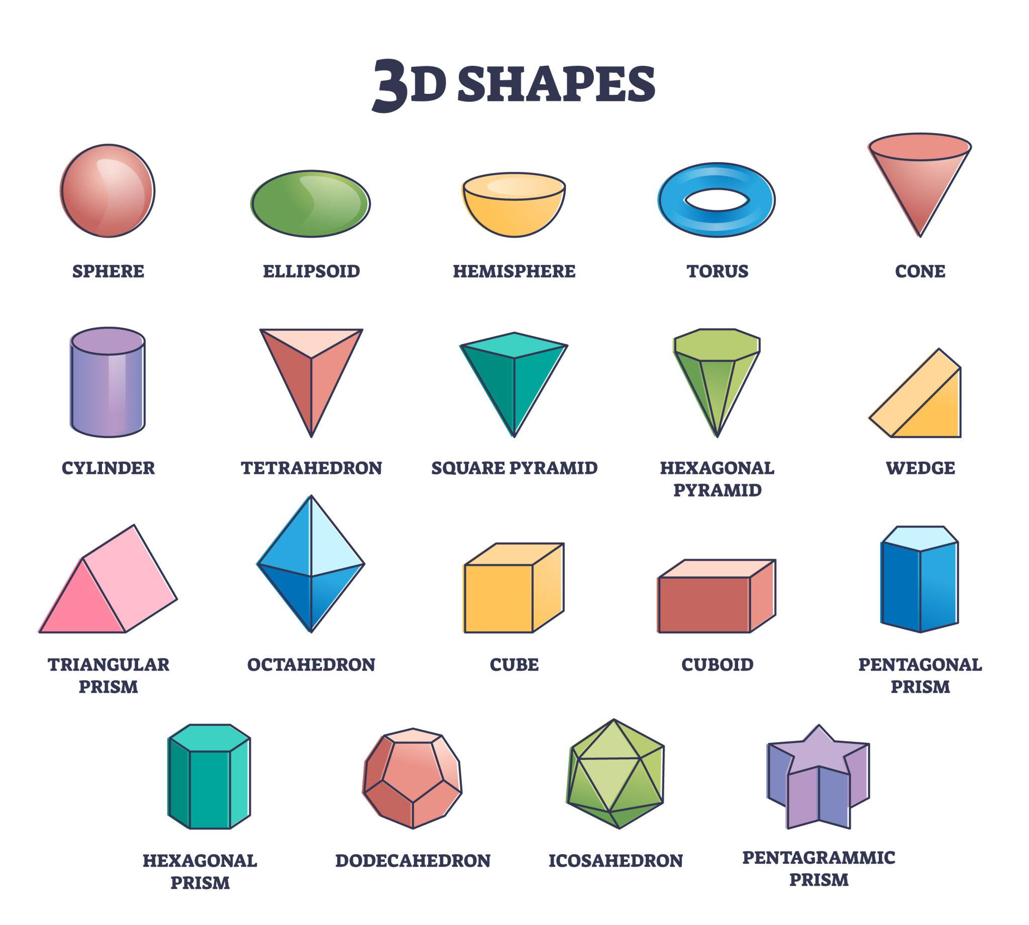
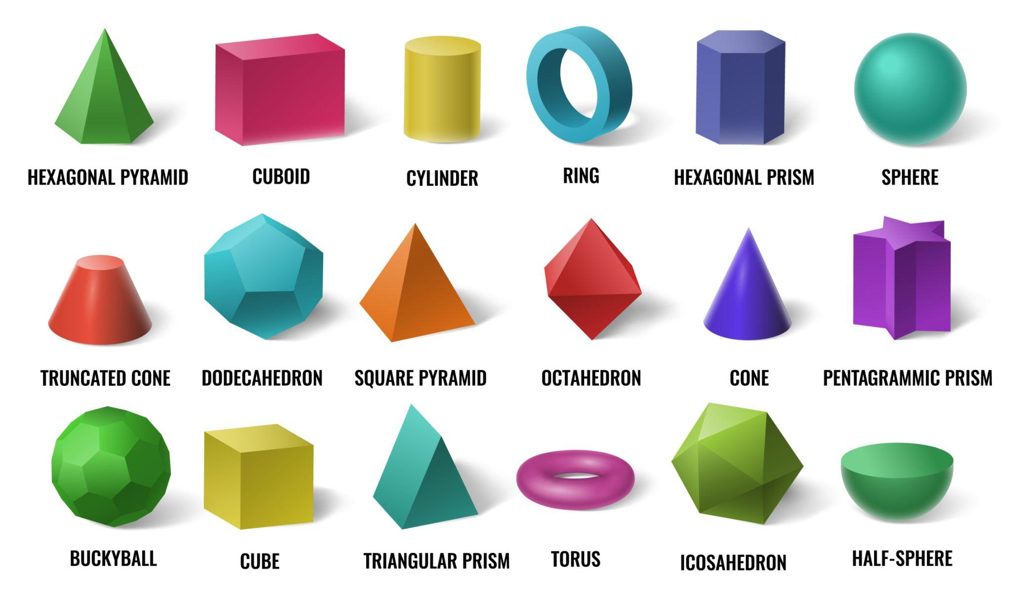
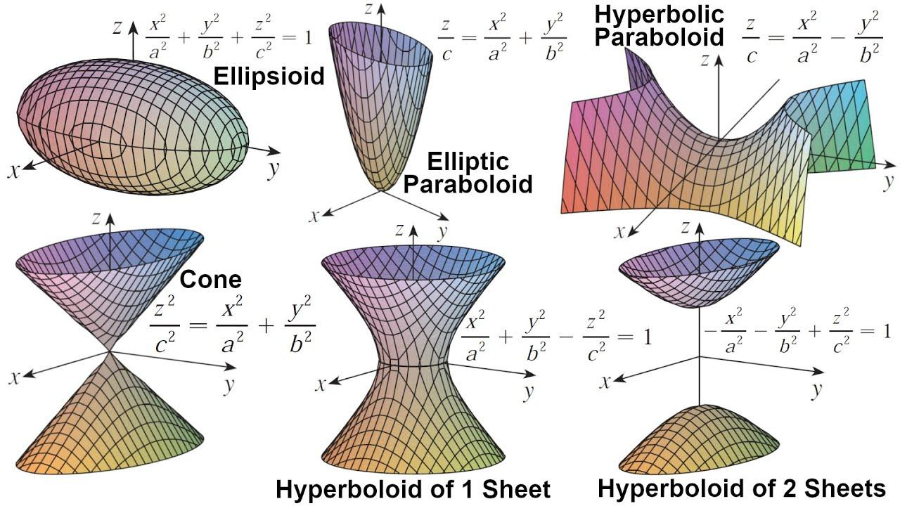
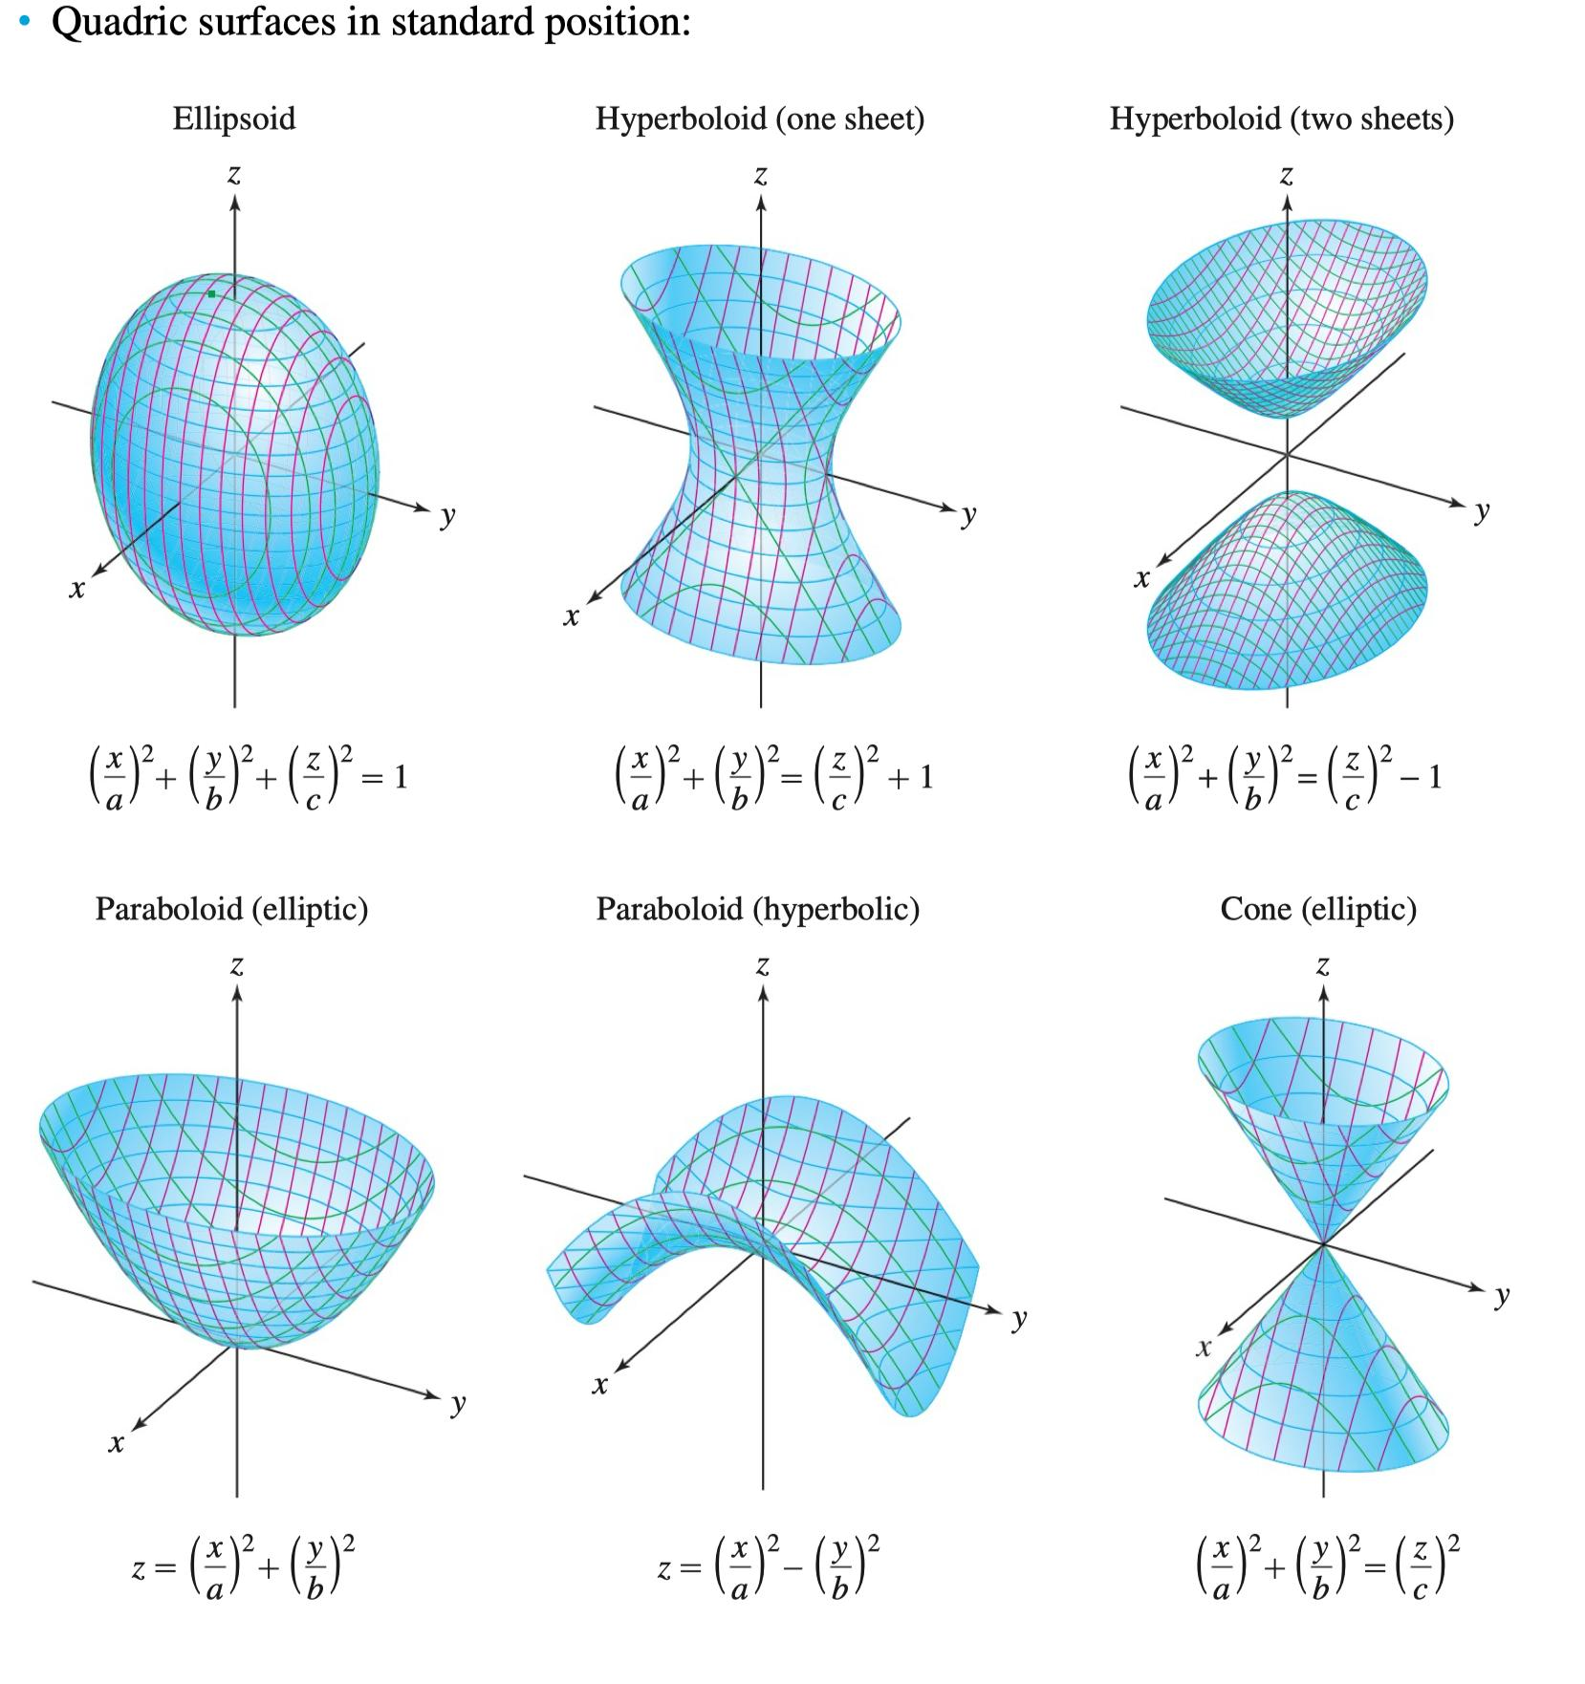
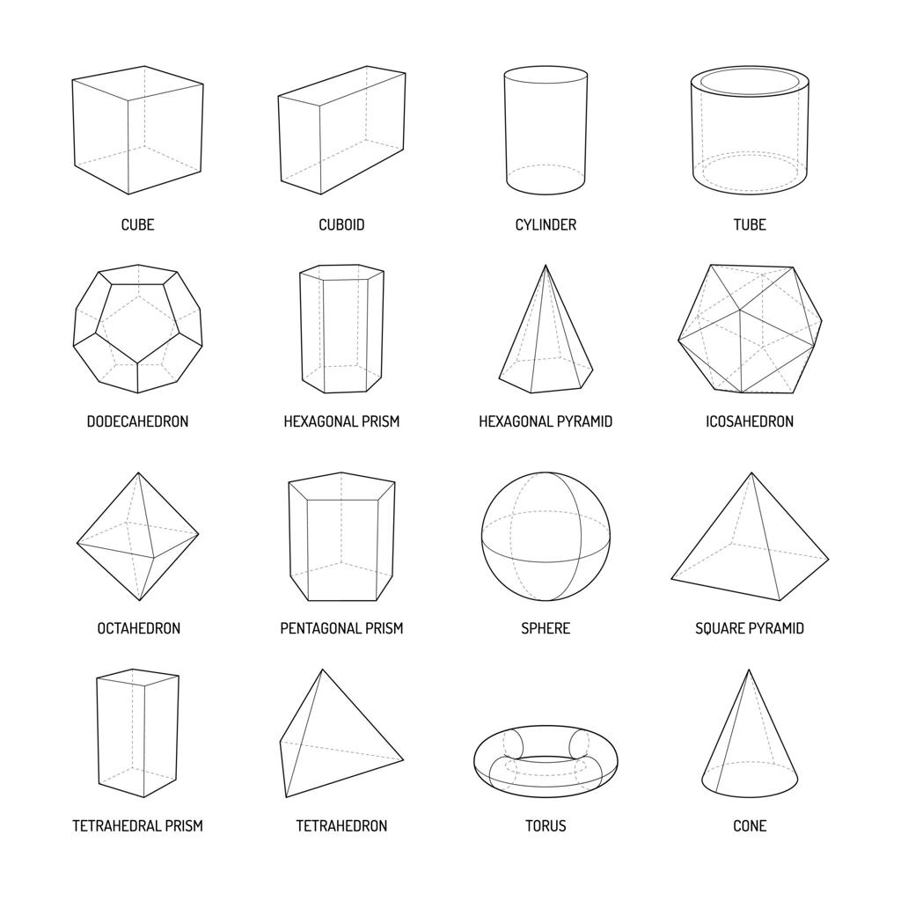These solids have at least one curved surface.
- Sphere: A solid whose surface points are all equally distant from its center.
- Cylinder: A solid with two parallel, congruent circular bases in the right circular case.
- Cone: A solid with a base that narrows to an apex in the circular-cone case.
- Torus: A ring-shaped solid.
- Other Curved Solids: Include ellipsoids and solids bounded by more complex curved surfaces.

Important Formulas
# Source: AI Source: Provided by: [Data Path: Persons Table -> ID Column: 1, Name_En Column: Motasem Essam] -> From: [ChatGPT] on [7/25/2026]
Let $a$ represent a cube's side length, $l$ the length, $w$ the width, $h$ the perpendicular height, $r$ the radius, $B$ the base area, $P$ the base perimeter, and $s$ the slant height where applicable.
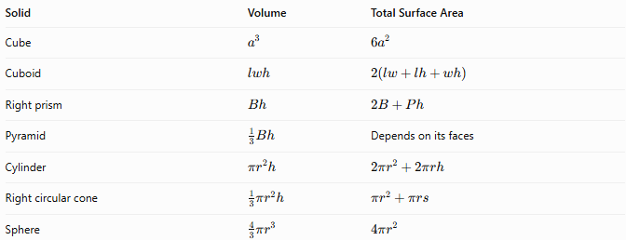
Solid | Volume | Total Surface Area
Cube | $$a^{3}$$ | $$6a^{2}$$
Cuboid | $$lwh$$ | $$2\left(lw+lh+wh\right)$$
Right prism | $$Bh$$ | $$2B+Ph$$
Pyramid | $$\frac{1}{3}Bh$$ | Depends on its faces
Cylinder | $$πr^{2}h$$ | $$2πr^{2}+2πrh$$
Right circular cone | $$\frac{1}{3}πr^{2}h$$ | $$πr^{2}+πrs$$
Sphere | $$\frac{4}{3}πr^{3}$$ | $$4πr^{2}$$
For a right circular cone, $s=\sqrt{r^{2}+h^{2}}$. The pyramid's surface area depends on the shape and dimensions of its individual faces.

Important Theorems and Topics
# Source: AI Source: Provided by: [Data Path: Persons Table -> ID Column: 1, Name_En Column: Motasem Essam] -> From: [ChatGPT] on [7/25/2026]
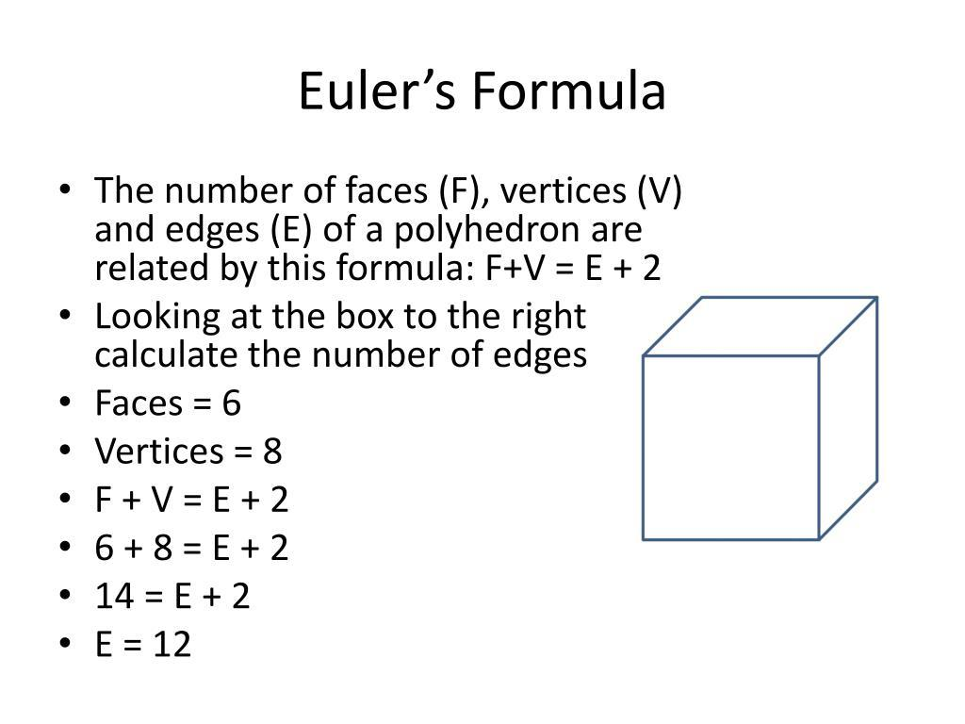
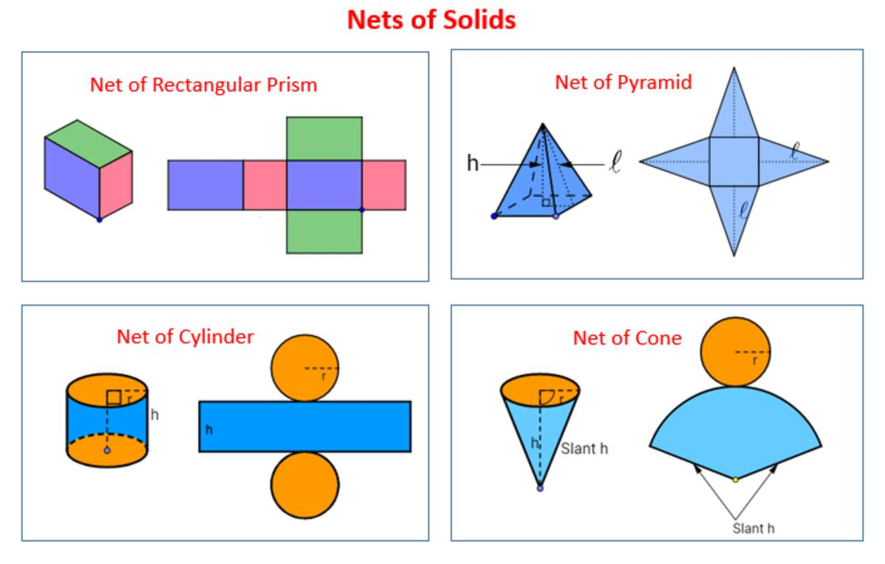
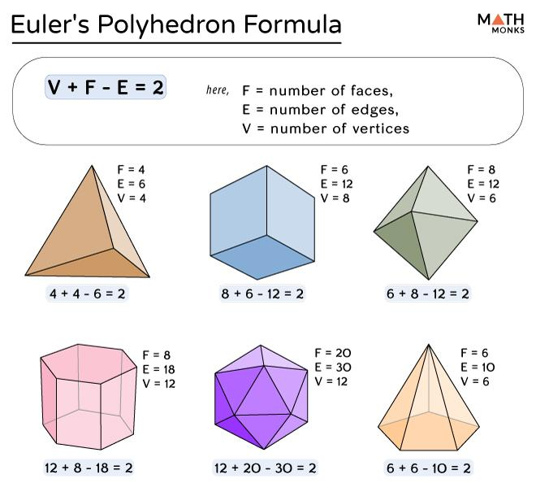
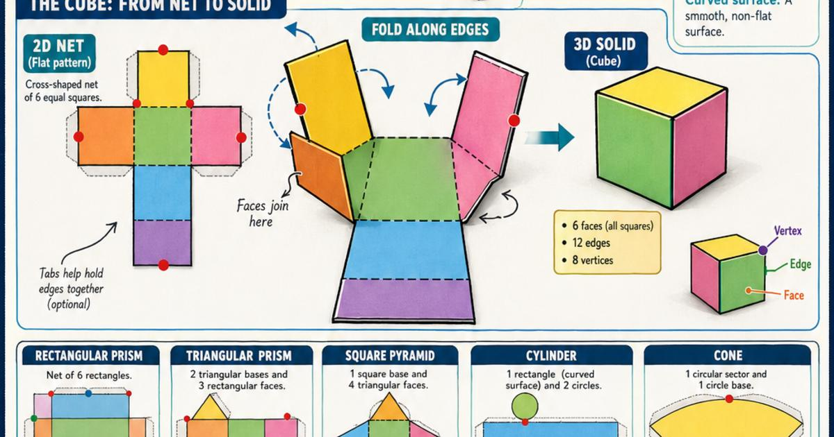
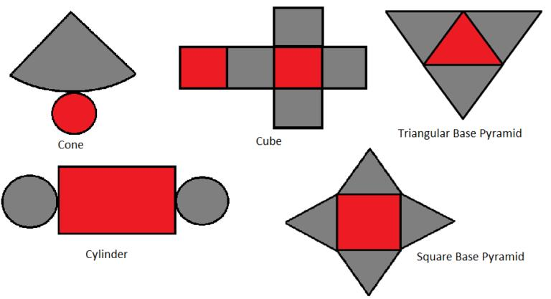
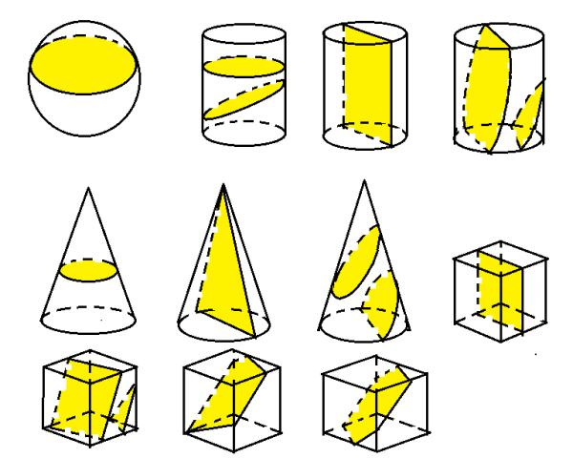

1 Euler's Polyhedron Formula
# Source: AI Source: Provided by: [Data Path: Persons Table -> ID Column: 1, Name_En Column: Motasem Essam] -> From: [ChatGPT] on [7/25/2026]
For a convex polyhedron,
$$V-E+F=2$$
where:
- $V$ = number of vertices
- $E$ = number of edges
- $F$ = number of faces
For example, a cube has 8 vertices, 12 edges, and 6 faces:
$$8-12+6=2$$

2 Cross-Sections
# Source: AI Source: Provided by: [Data Path: Persons Table -> ID Column: 1, Name_En Column: Motasem Essam] -> From: [ChatGPT] on [7/25/2026]
A cross-section is the two-dimensional figure produced when a plane intersects a solid. Depending on the solid and the plane's orientation, the cross-section may be a circle, triangle, rectangle, or another shape.

3 Nets of Solids
# Source: AI Source: Provided by: [Data Path: Persons Table -> ID Column: 1, Name_En Column: Motasem Essam] -> From: [ChatGPT] on [7/25/2026]
A net represents the flat arrangement of a solid's surfaces before they are folded into three dimensions. Nets help visualize surface area and understand how solids are constructed.

4 Spatial Relationships
# Source: AI Source: Provided by: [Data Path: Persons Table -> ID Column: 1, Name_En Column: Motasem Essam] -> From: [ChatGPT] on [7/25/2026]
Solid Geometry also studies the relationships between objects in space, including:
- Parallel and perpendicular lines.
- Parallel and perpendicular planes.
- Angles between lines and planes.
- Distances between points, lines, and planes.

Applications
# Source: AI Source: Provided by: [Data Path: Persons Table -> ID Column: 1, Name_En Column: Motasem Essam] -> From: [ChatGPT] on [7/25/2026]
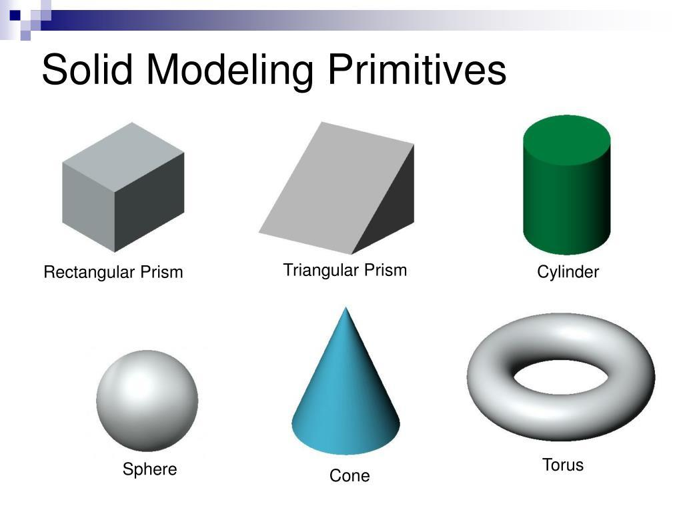
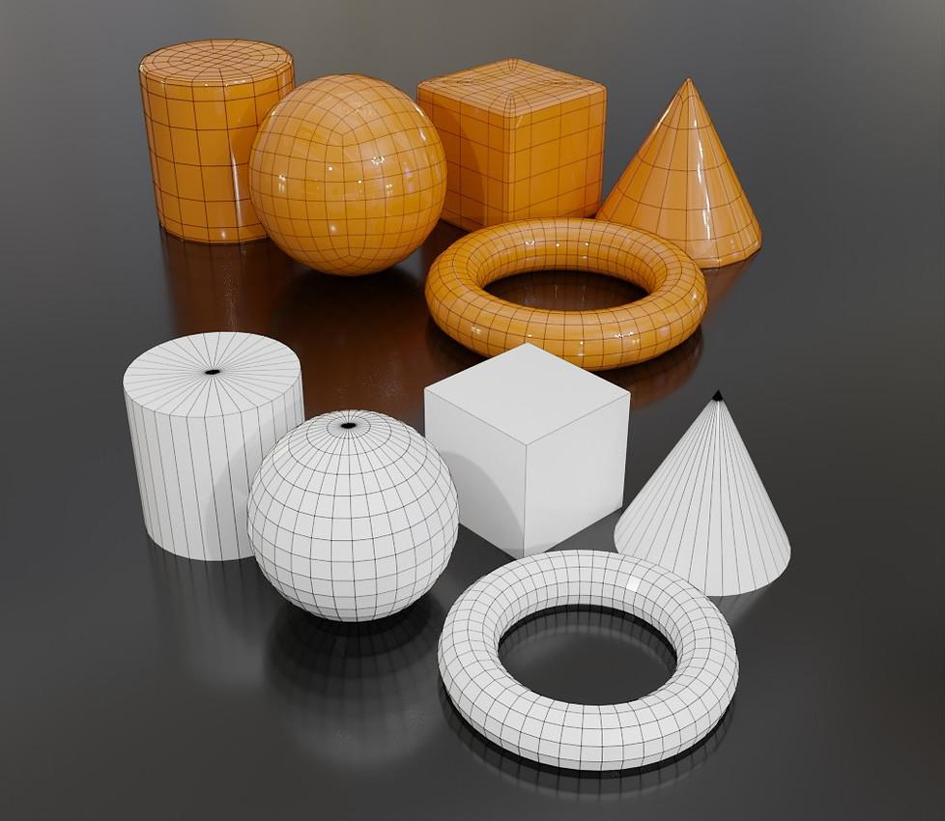
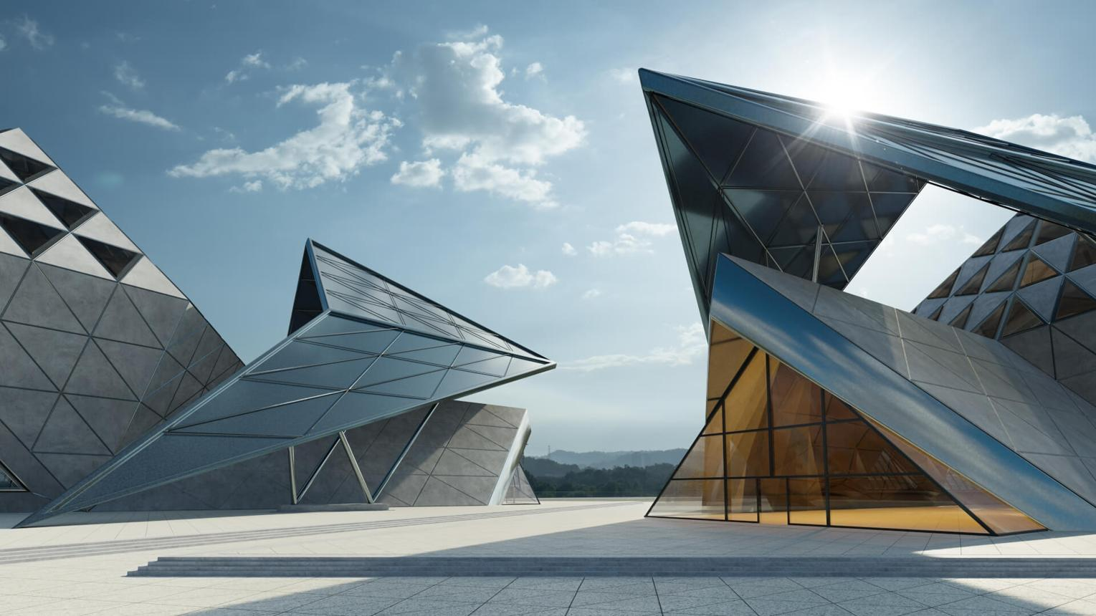
Solid Geometry is useful in:
- Architecture: Designing buildings and understanding spatial dimensions.
- Engineering: Modeling mechanical components and calculating material requirements.
- Manufacturing: Determining product dimensions, volume, and surface area.
- Computer Graphics: Creating and manipulating three-dimensional models.
- Physics: Studying physical objects and their spatial properties.
- Packaging: Designing containers and optimizing material usage.

Solid Geometry vs. Plane Geometry
# Source: AI Source: Provided by: [Data Path: Persons Table -> ID Column: 1, Name_En Column: Motasem Essam] -> From: [ChatGPT] on [7/25/2026]
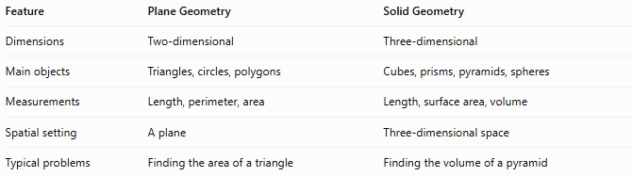
Feature | Plane Geometry | Solid Geometry
Dimensions | Two-dimensional | Three-dimensional
Main objects | Triangles, circles, polygons | Cubes, prisms, pyramids, spheres
Measurements | Length, perimeter, area | Length, surface area, volume
Spatial setting | A plane | Three-dimensional space
Typical problems | Finding the area of a triangle | Finding the volume of a pyramid

Relationship to Other Branches of Geometry
# Source: AI Source: Provided by: [Data Path: Persons Table -> ID Column: 1, Name_En Column: Motasem Essam] -> From: [ChatGPT] on [7/25/2026]
- Euclidean Geometry: Solid Geometry studies three-dimensional Euclidean space and is commonly considered the spatial counterpart of Plane Geometry.
- Analytic Geometry: Uses coordinates and equations to represent and analyze objects in three-dimensional space.
- Differential Geometry: Studies smooth curves and surfaces, including curvature.
- Computational Geometry: Develops algorithms for three-dimensional shapes and spatial relationships.
- Projective Geometry: Studies geometric properties preserved by projective transformations, including projections of three-dimensional objects.

Conclusion
# Source: AI Source: Provided by: [Data Path: Persons Table -> ID Column: 1, Name_En Column: Motasem Essam] -> From: [ChatGPT] on [7/25/2026]
Solid Geometry is the branch of geometry concerned with three-dimensional shapes and the properties of space. It studies polyhedra, curved solids, spatial relationships, surface areas, volumes, cross-sections, and nets.
Its fundamental concepts provide the foundation for understanding how objects occupy space, how their dimensions relate to one another, and how their geometric properties can be calculated.
Solid Geometry connects Plane Geometry with practical three-dimensional applications in architecture, engineering, manufacturing, physics, and computer graphics.

